### 一、简历

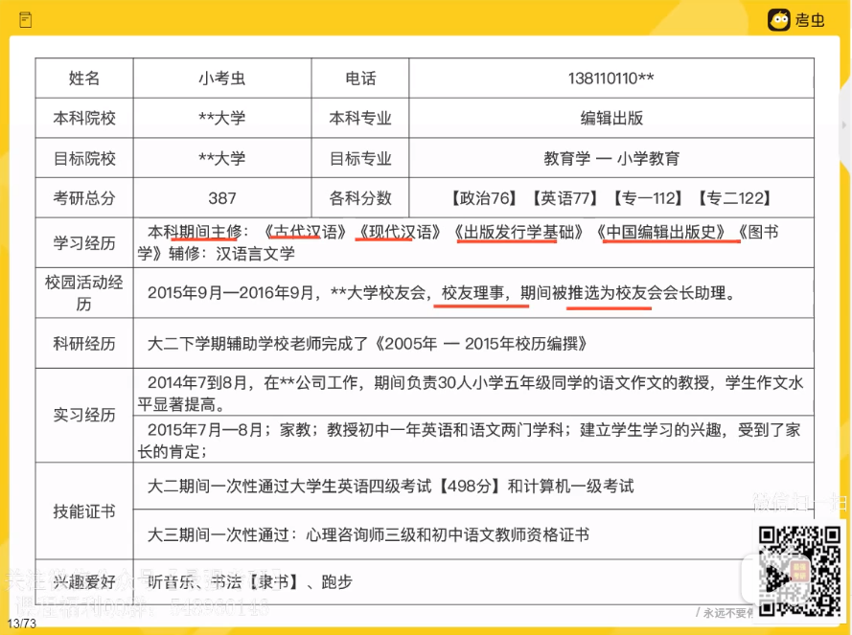

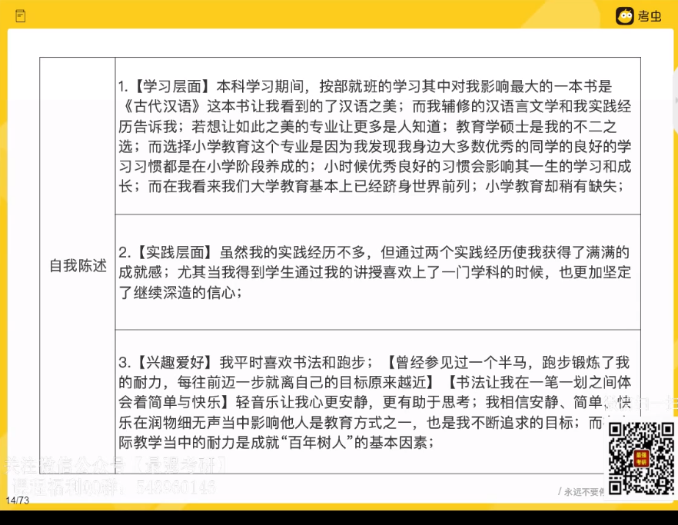

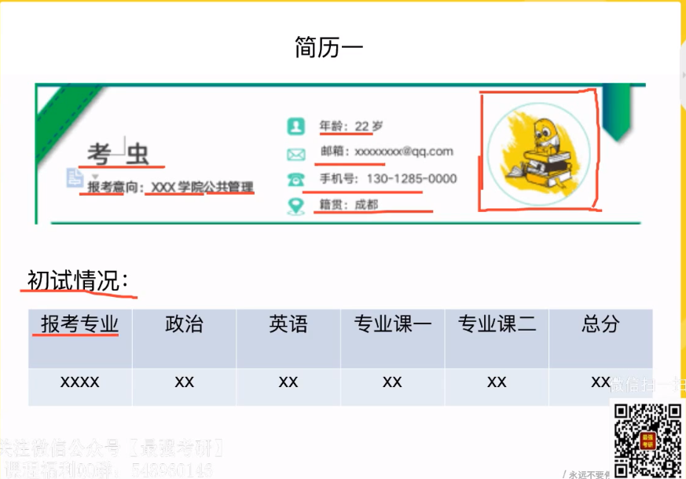

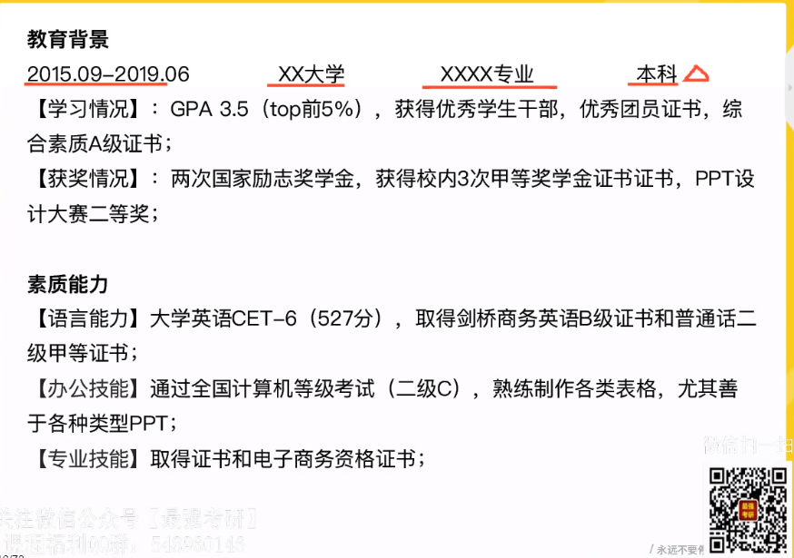

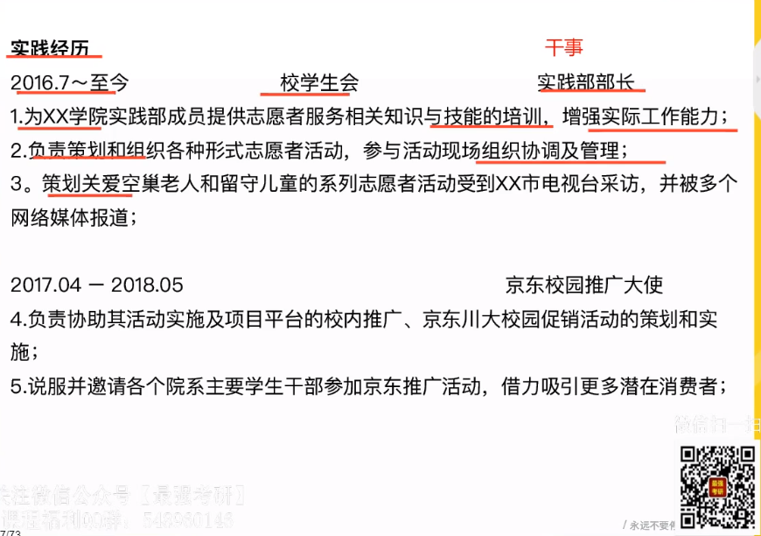

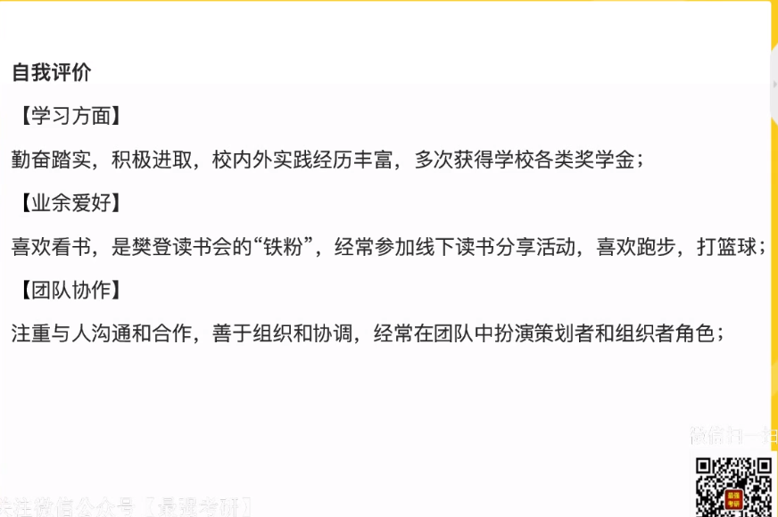

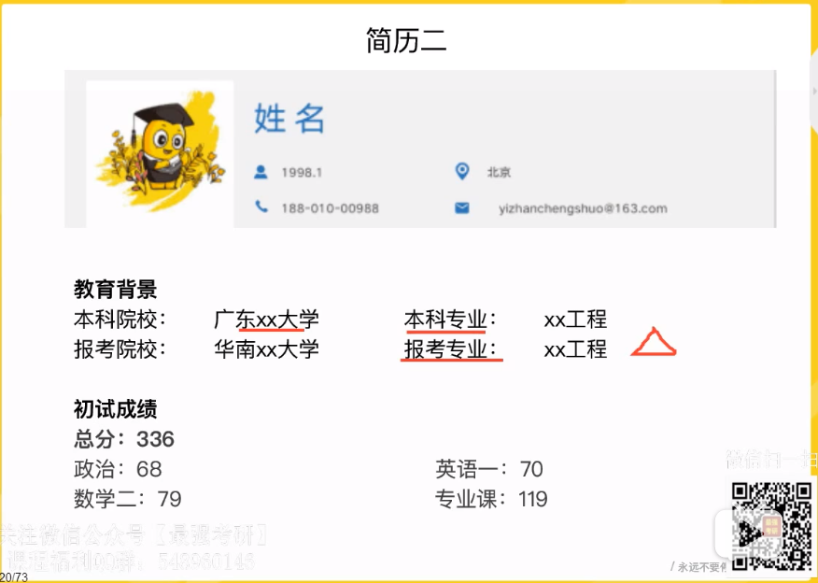

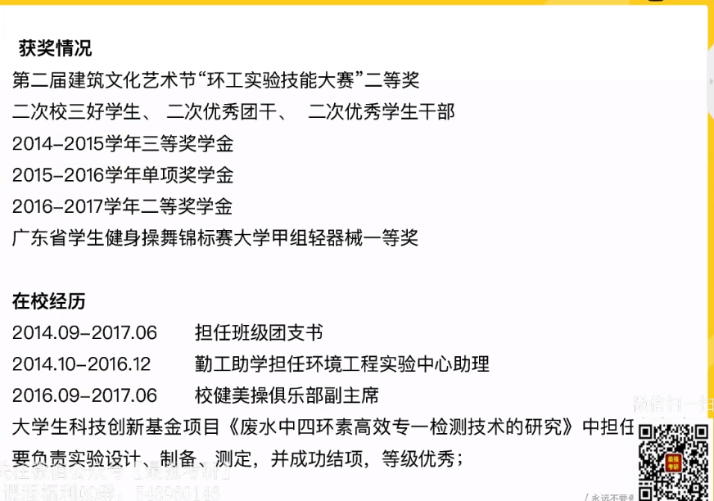

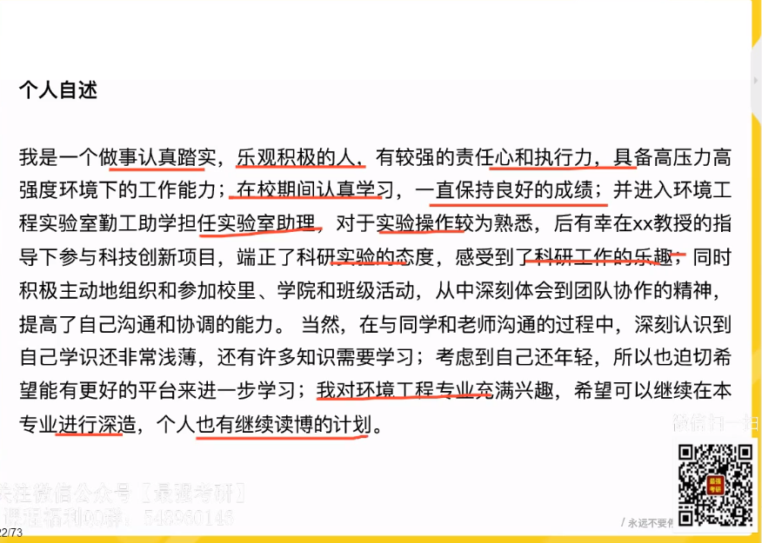

简历二：获奖多+无科研

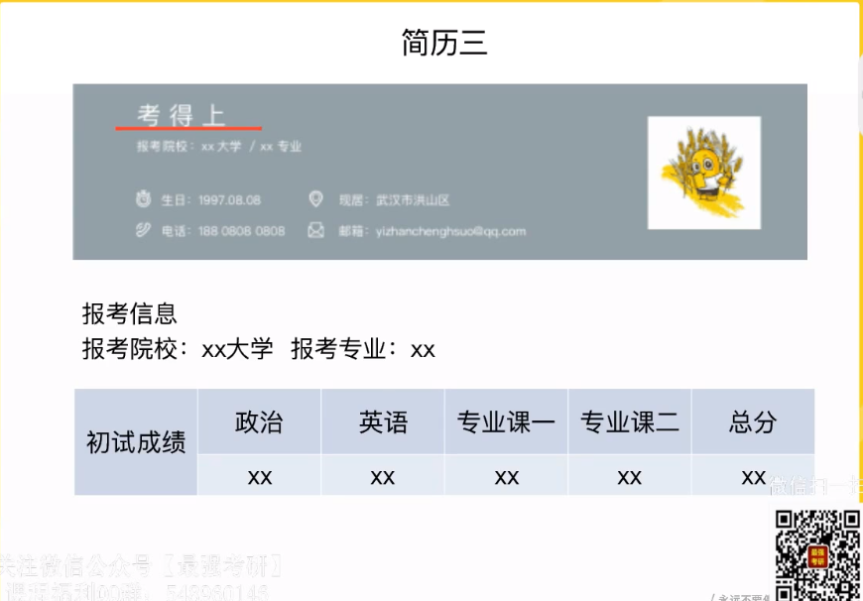

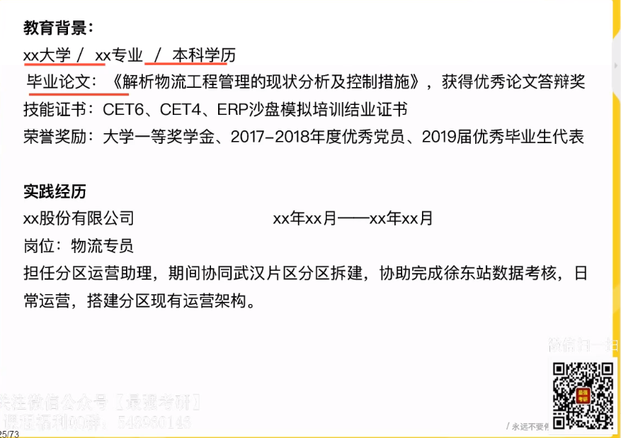

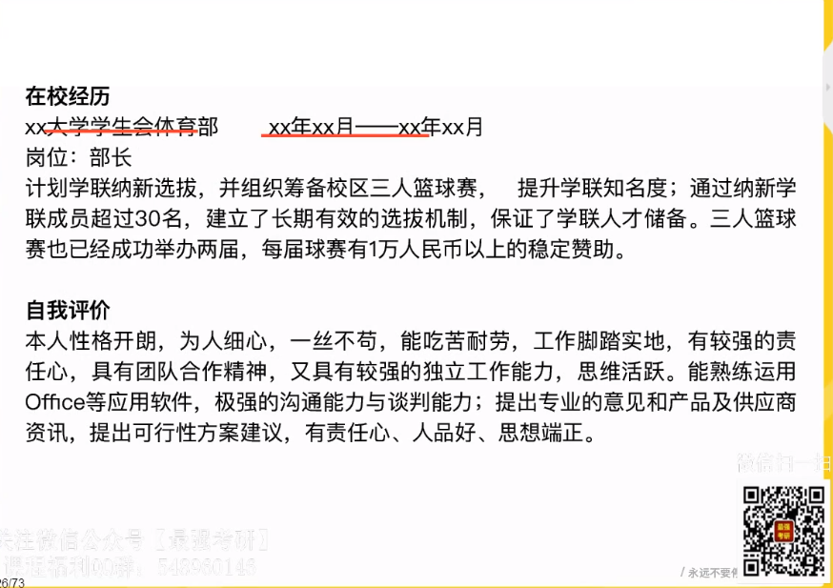

简历三：

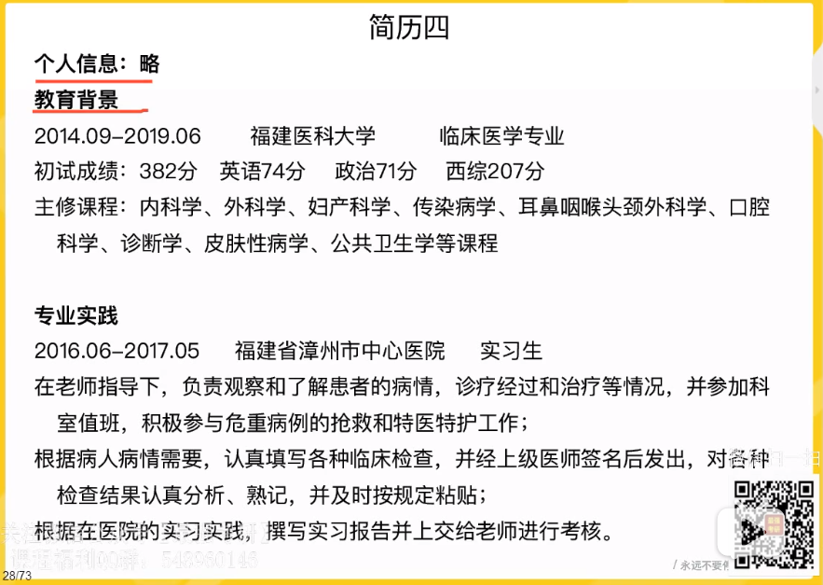

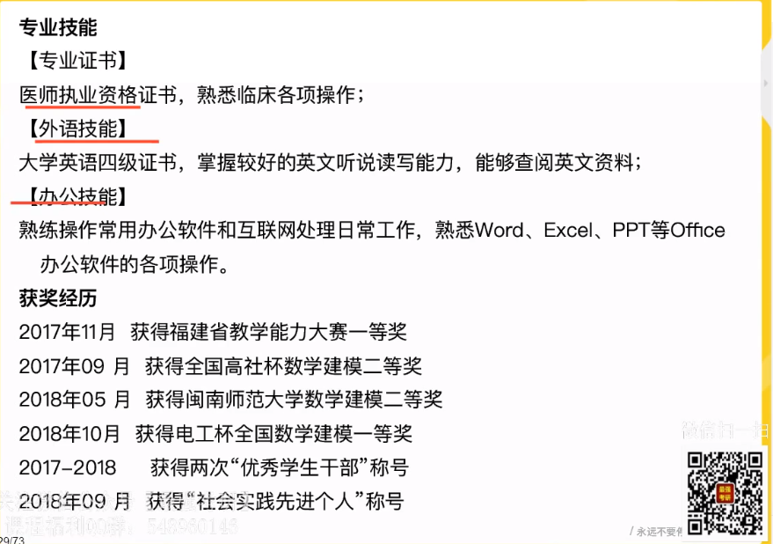

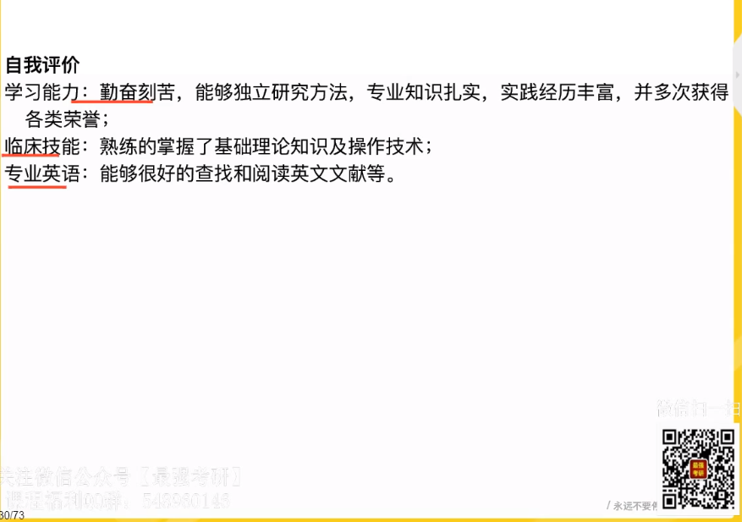

简历四、医学

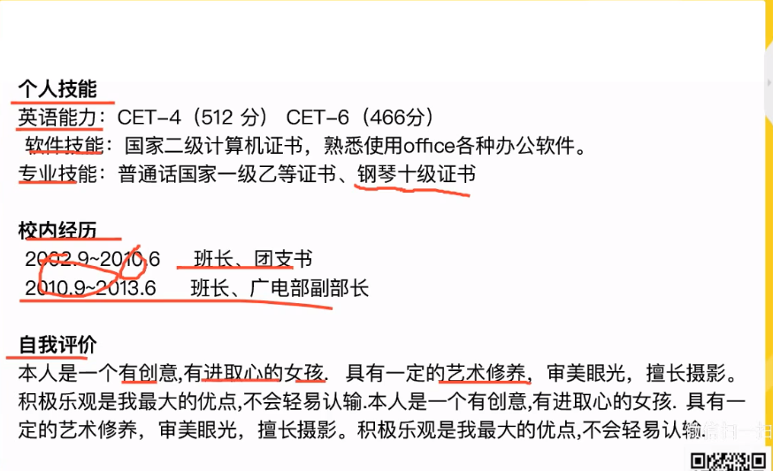

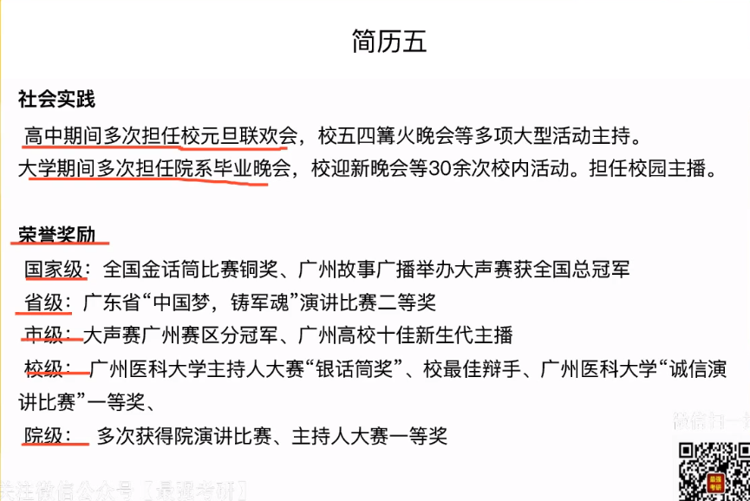

简历五、实践经验差 无科研

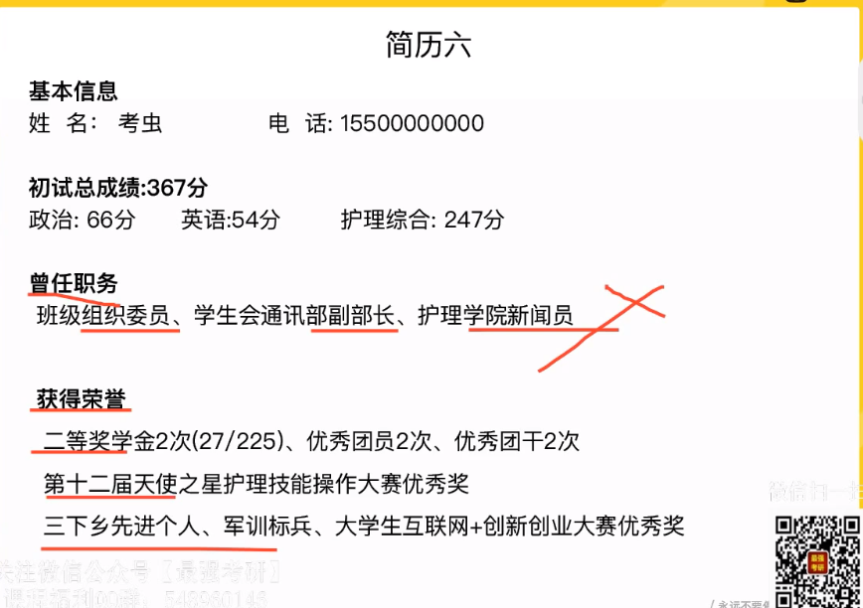

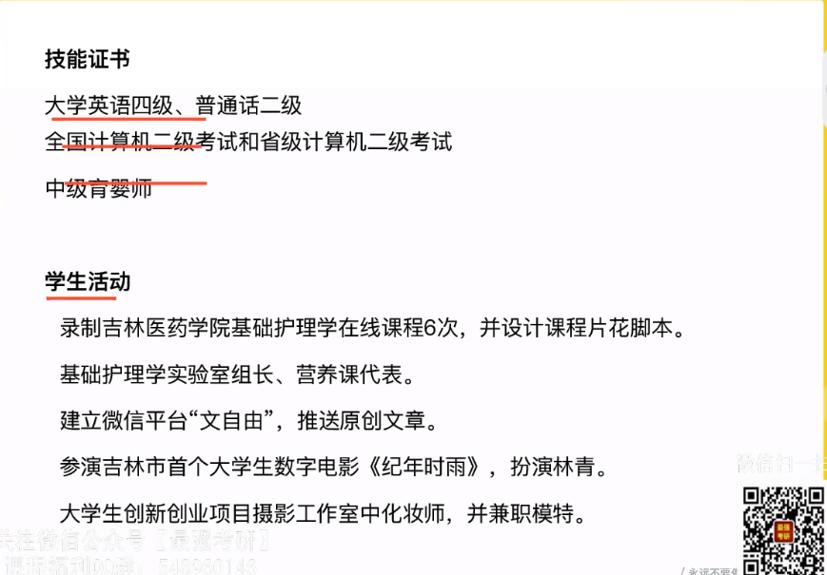

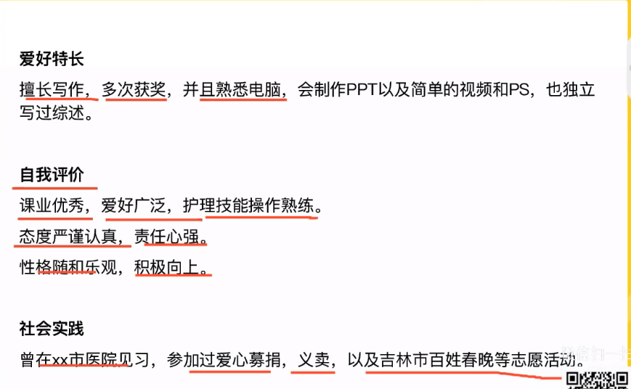

简历六：

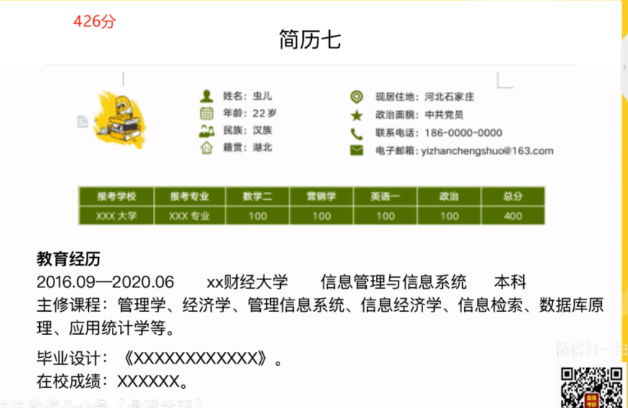

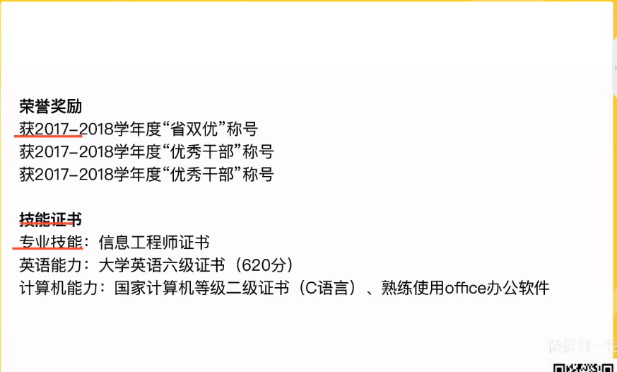

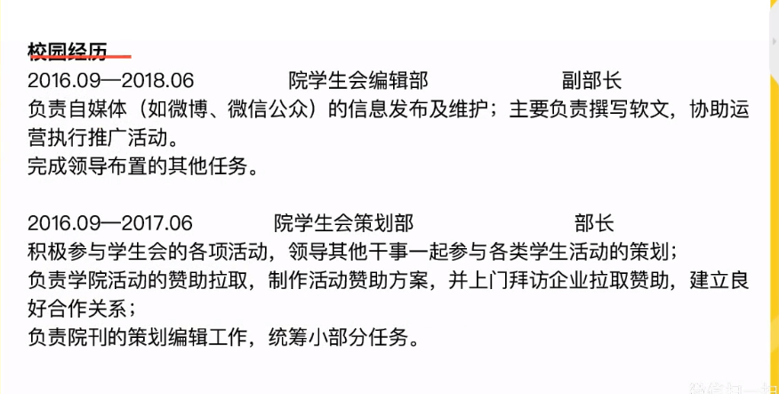

简历七

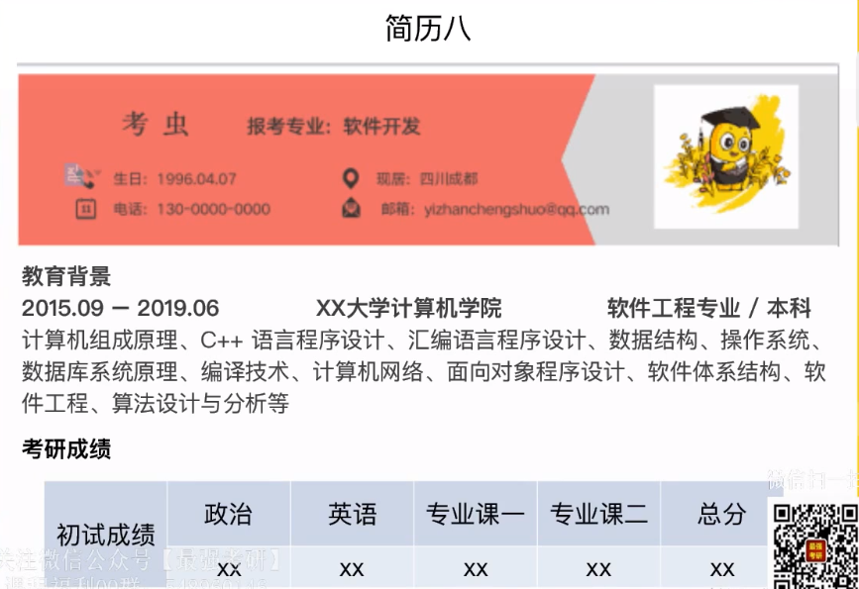

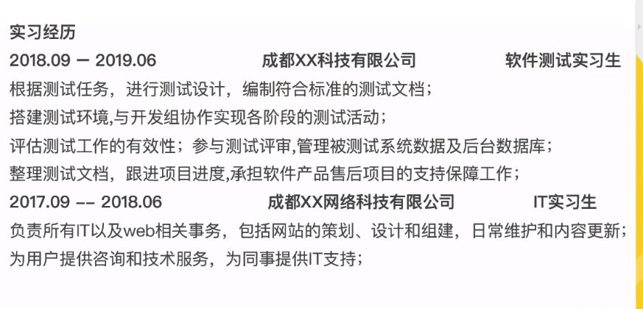

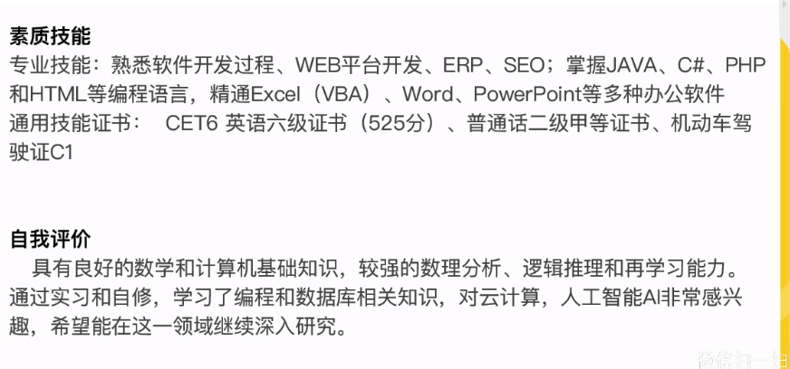

简历八：

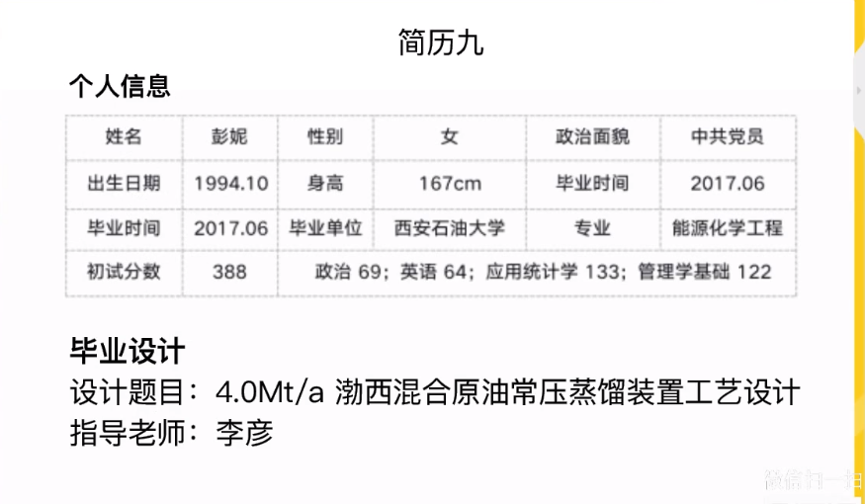

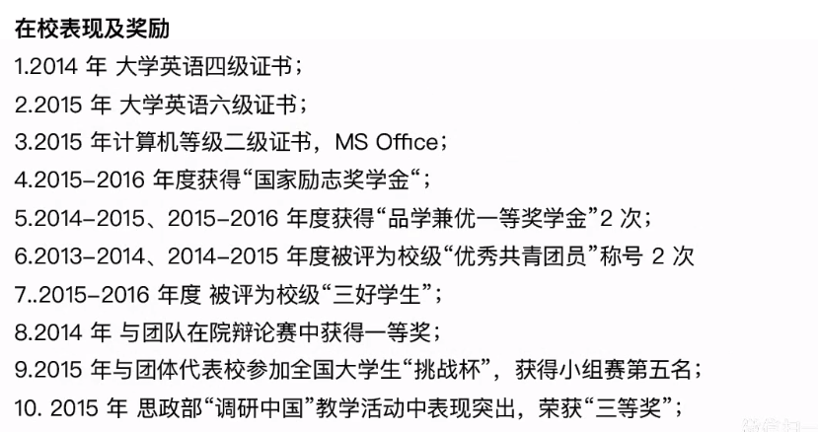

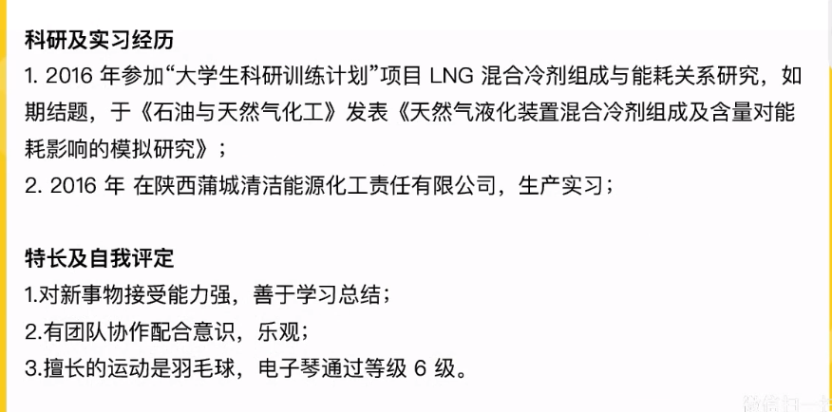

简历九：科研多

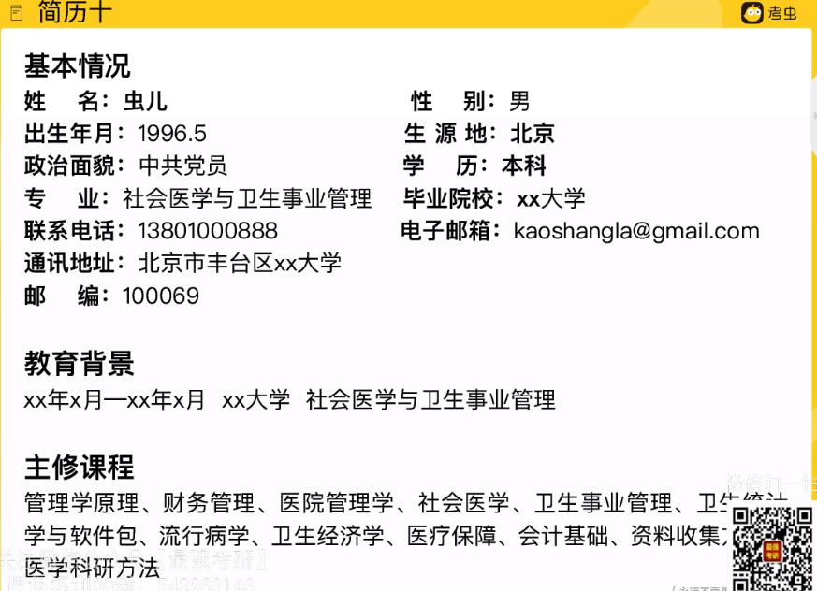

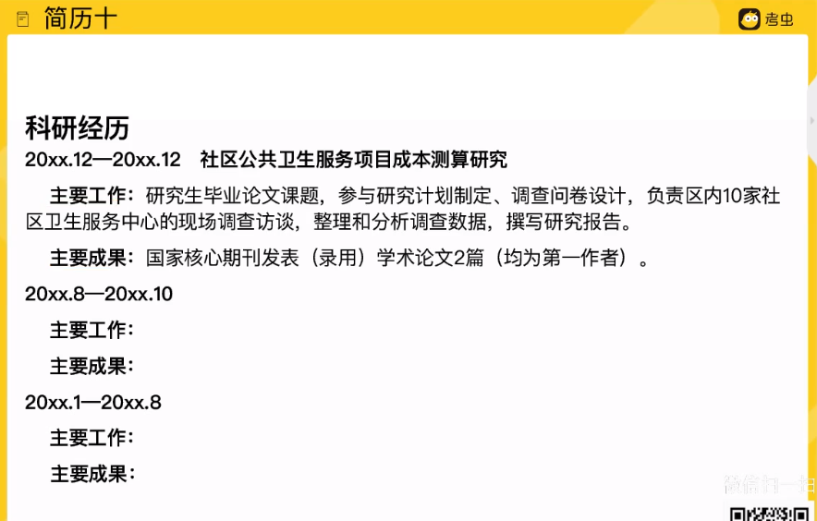

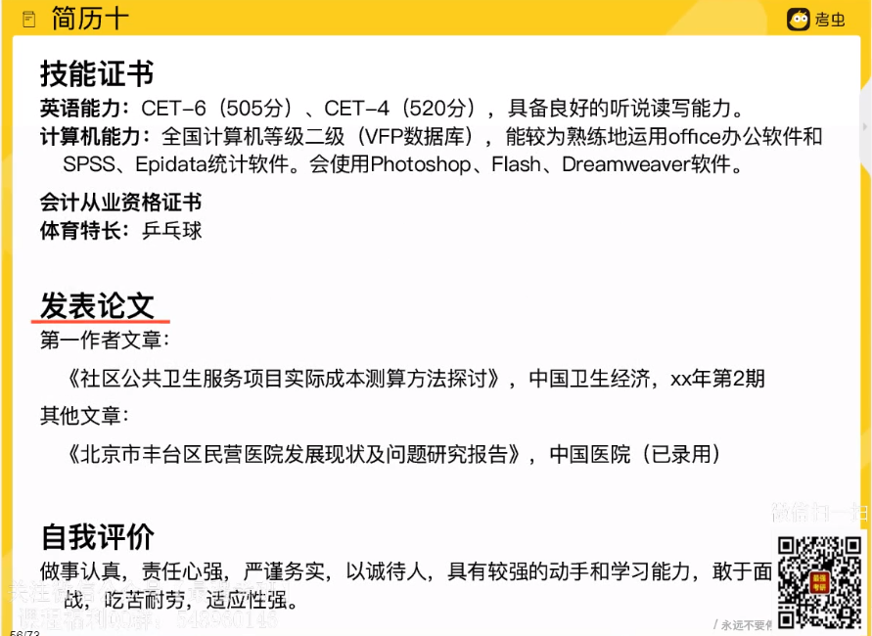

简历十：学霸型

在职：工作经历 素质能力 获奖情况 自我评价

1. 自荐信

封面+个人简历+证书+自荐信

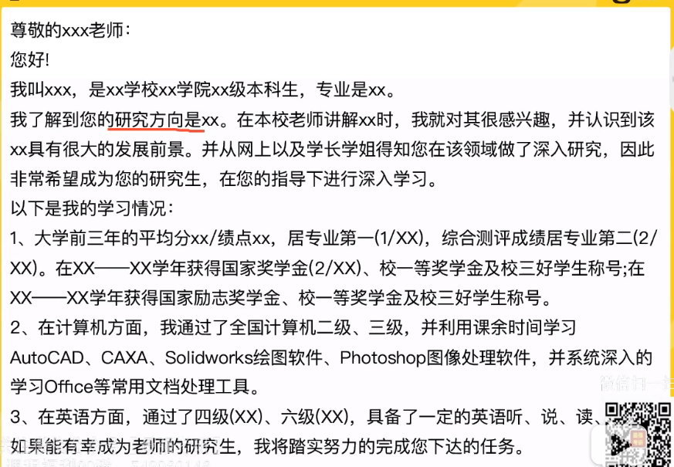

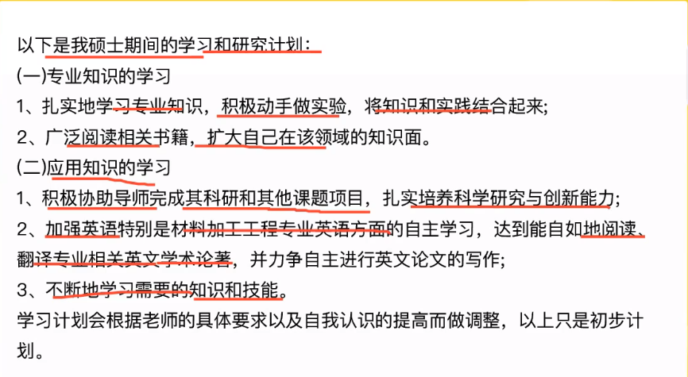

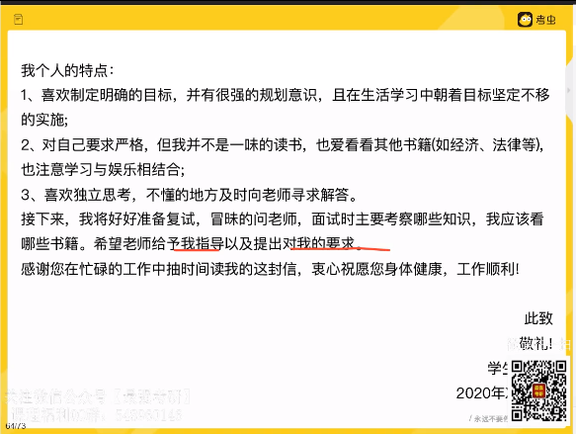

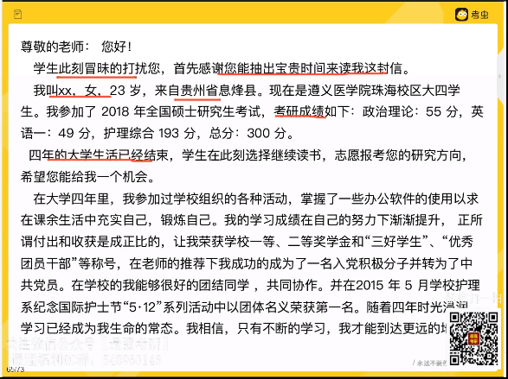

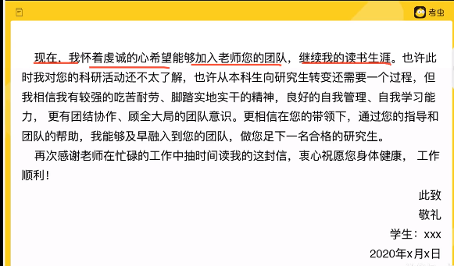

复试：简历+证书复印件+自荐信

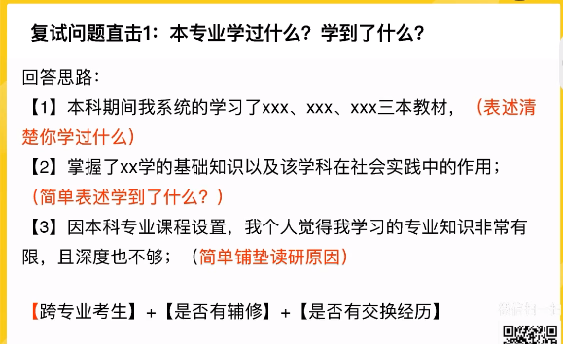

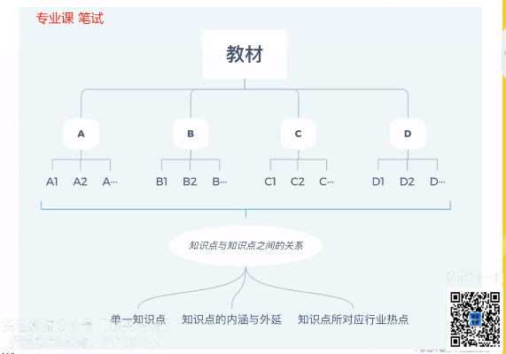

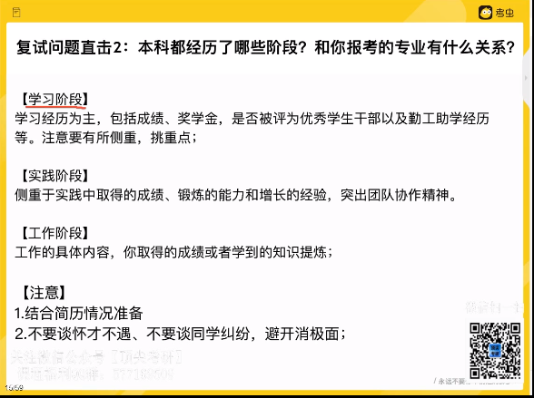

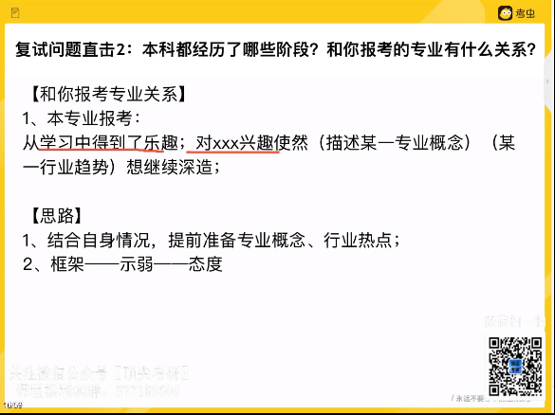

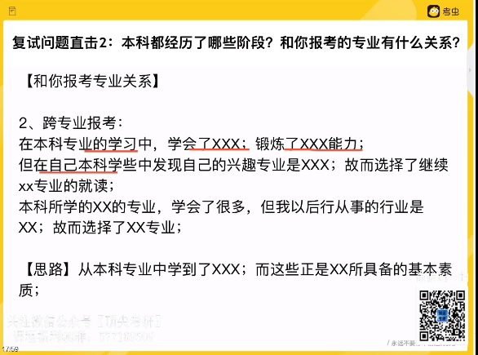

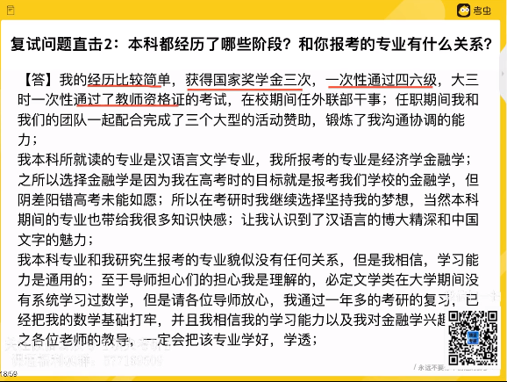

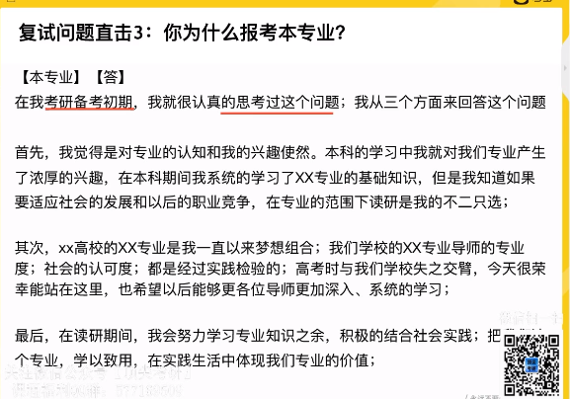

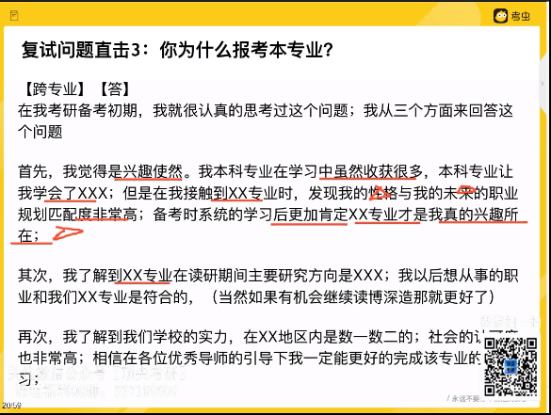

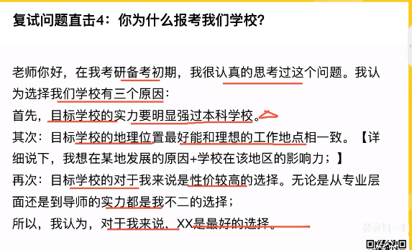

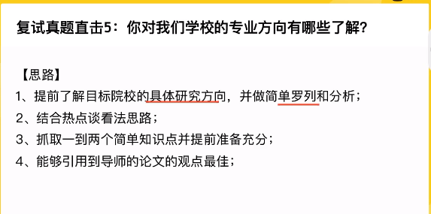

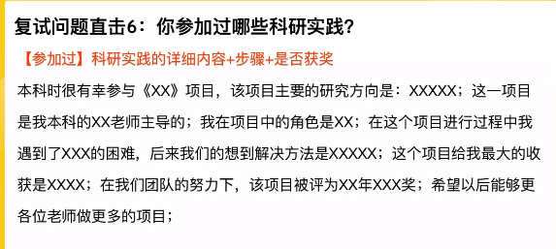

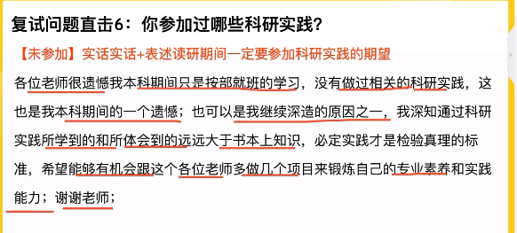

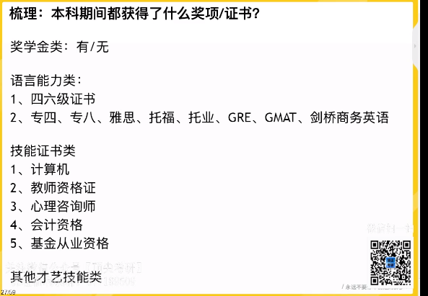

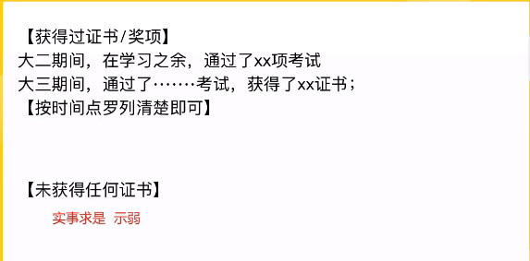

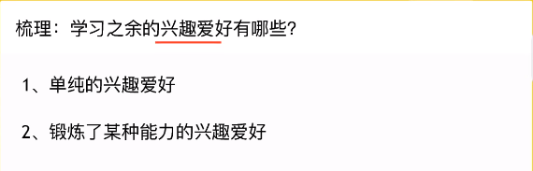

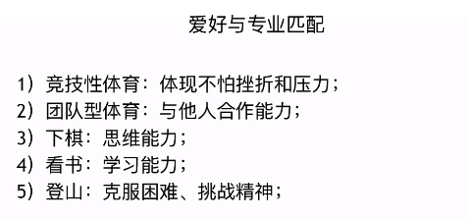

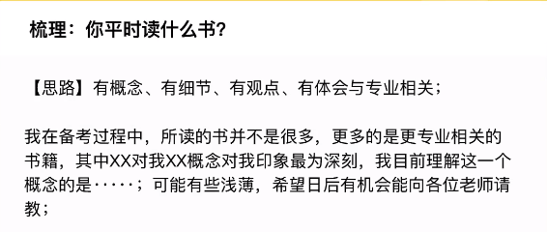



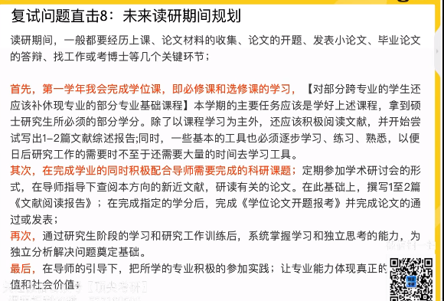

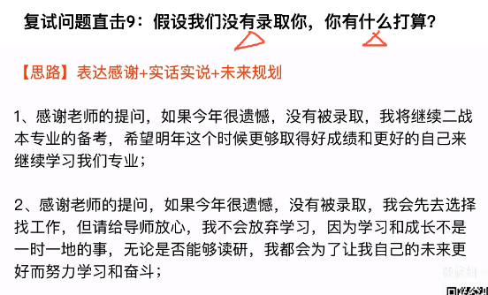

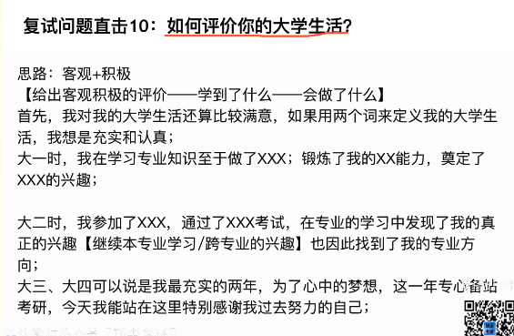

自我介绍：

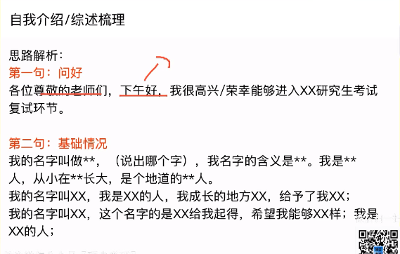

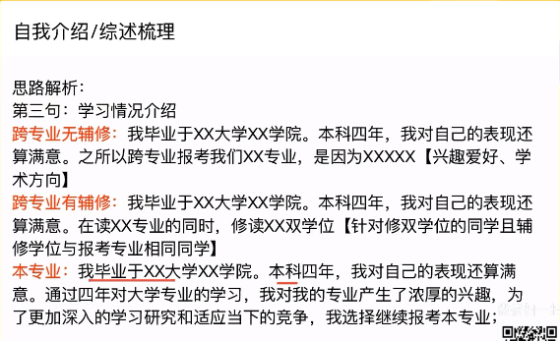

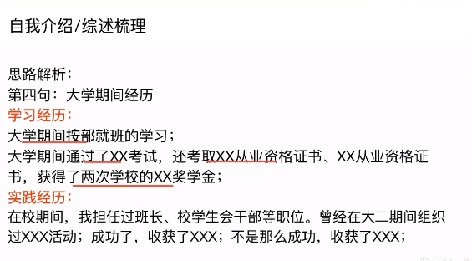

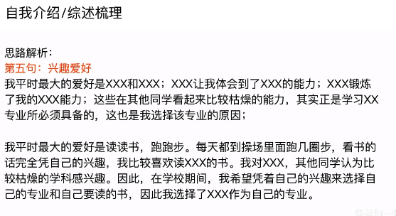

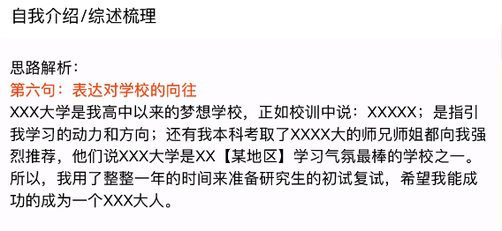

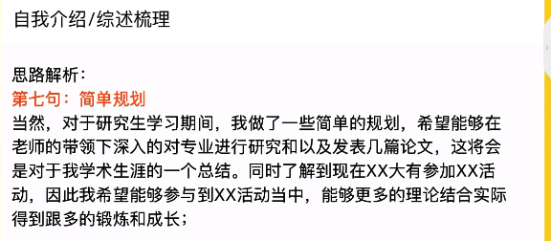

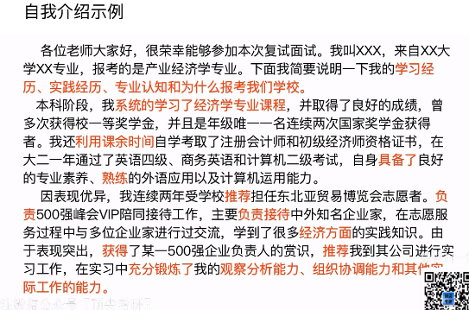

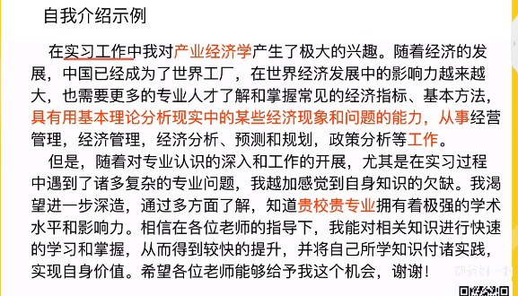



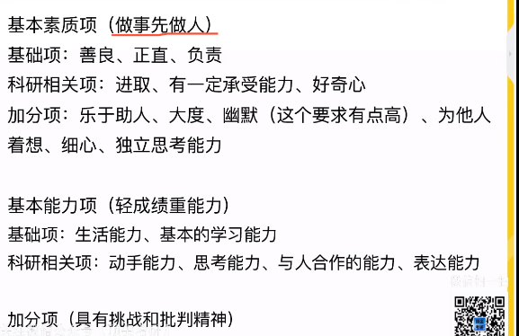

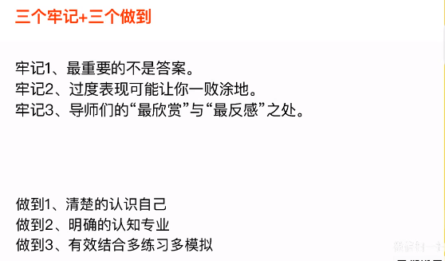

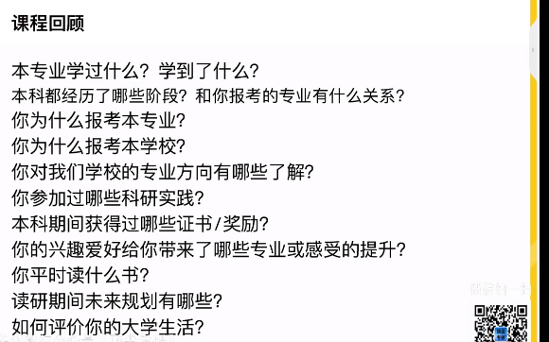

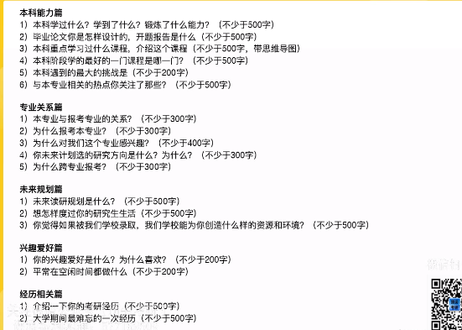

### 复试英语

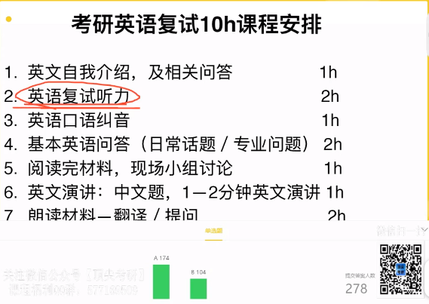

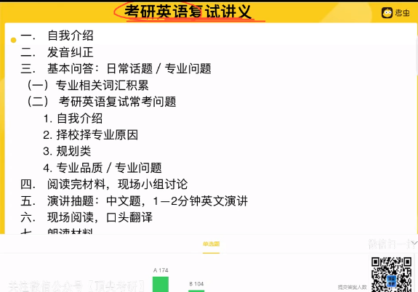

面试：自我介绍/问答

1. 自我介绍的作用？应该介绍什么？

A充分展示自己know your strength weakness

B 吸引导师，让导师看到你的潜力

Brainstorming 头脑风暴写出是个优点

自我介绍提问形式：

Could you please introduce yourself?

Tell me something about yourself?

Would you please make a brief introduction about yourself?

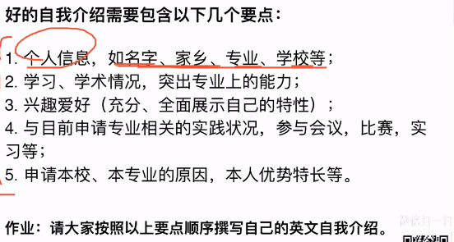

1、个人信息：

Good morning,dear professors,My name is Liu Fend,I am 21 years old.And i come from Shijiazhuang ,Hebei Province.As you can see,I have a nice personality and i am very easy to get along with.

1. 专业背景：

自己的学习。学术情况 突出专业上的能力

I major in English at Shandong University.In the past 3 and a half years,I spent most of my time on study.I guess i am a good student,because my GPA is 3.64,which helped me to rank on top of my class,and my CET6 score is 631,Scores don’t mean anything ,but they do reflect my efforts and dedication to study,I also passed CATT1 Level2 and i have acquired the basic knowledge of English both in theory and in practice.

I am currently a senior student at Hebei University ,majoring in English.

1. 兴趣爱好

Honestly speaking,I’m proud of my ability to persevere and overcome challenged.This year i was having a hard time learning the class interpreting.But i met with the teacher outside of class and committed to studying for 3 hours a day ,and ended up with an A in the class.I’m also really passionate about my interests,especially English and public speaking.That’s why i am a member of the English club and the president of Public Speaking Club.

参考1：But please don’t take me as a boring person.I am also interested in other activities,such as swimming and running,both of which help me to become an active person with a lot of determination ,I get up early every day and exercise on campus.

参考2：Well ,in my spare time ,i have intense interest in playing basketball,tennis and Chinese chess.Also English is my favorite subject.I often go to English corner to practice my oral English on every Thursday ,and write compositions to improve my writing skills

1. 实习

Besides,i did an internship in a local company during the last summer holiday,I was taking charge of the meeting arrangements and business trip booking.This experience brought me deeper understanding of how the business system works.Therefore ,i had an early introduction to the world of business and entrepreneurship.

1. 申请本校

What’s more,my intense interest in my major affirmed my desire to pursue a higher degree on interpreting at this university.I love the atmosphere of this campus ,which is full of passion and youthful spirit .Studying in “” university can help me to meet top students and scholars.Therefore ,i believe it can bring my academic research to a higher level.

